**Faculty Profile**

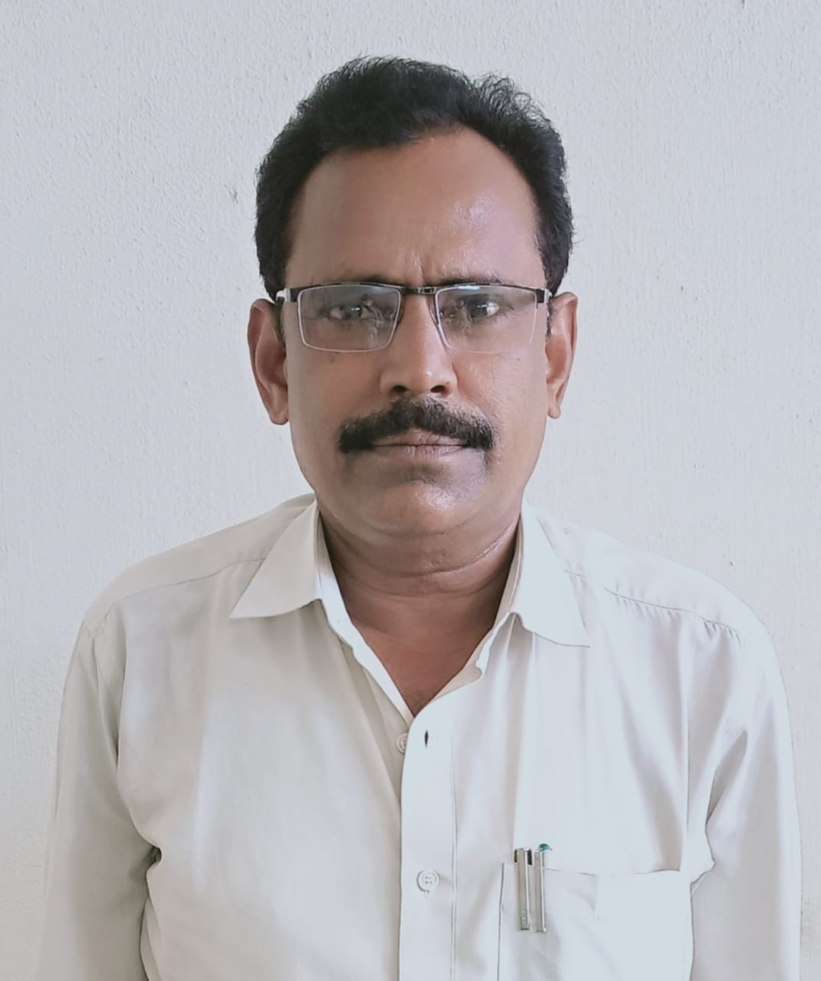

Name : Sri B Prakasam

Qualification : M.A (Ph.D)

Experience : 10 Years

Contact Number :9490187492

Email : [bpm4487@gmail.com](mailto:bpm4487@gmail.com)

| **S.No** | **Name of the Training** | **Name of the Training Institute** | **State** | **District** | **Period of Training** |
| --- | --- | --- | --- | --- | --- |
| 1 | Induction Training Programme | Commissionerate of Collegiate Education | Andhra Pradesh | Rajahmundry | 26-12-2001 to 31-12-2011 |
| 2 | Orientation Course | ASC MAANU | Telangana | Hyderabad | 09-04-2013 to 06-05-2013 |
| 3 | Refresher Course | HRDC Osmania | Telangana | Hyderabad | 23-08-2018 to 15-09-2018 |
| 4 | Refresher Course | HRDC Sri Venkateswara | Andhra Pradesh | Tirupathi | 24-02-2021 to 09-03-2021 |

* UGC Sponsored National Seminar on Status of Women in India during 20th Century - A Historical perspective presented a paper “ The status of Women in Indian Politics” at DAR College, Nuziveedu on 6th and 7th Septmber 2013.
* UGC Sponsored National Seminar on Human Rights in India - Contemporary Trends- presented a paper “Religious freedom in fundamental Human Right, Sri ASNM Government Degree College, Palakol on 10th and 11th December 2014.
* UGC Sponsored National Seminar on Human Rights A Study and Review , presented a paper Violation of Women Human Rights, DAR College, Nuzvid 17th and 18th December 2014.
* Two day National workshop on “Amaravathi -The new Capital of Andhra Pradesh vision & Mission organized by the Department of History, Political, Public Admints SRR & CVR Government Degree College, Vijayawada on 27th and 28th September 2016.
* Two day National Seminar on New Education Policy goals and imperatives organized by PB Siddhartha College of Arts and Science College & APSHE Amaravathi during 14-15 March 2017.
* One day State level workshop on cluster electives of CBCS through Virtual Classrooms. Organized by SRR & CVR Government Degree College, Vijayawada on 06-12-2017.
* One day District level workshop on Project work at UG level in cluster paper organized by SRR & CVR Government Degree College, Vijayawada on 15-02-2018.
* UGC Sponsored one day National workshop on “ Benefits and challenges of Interdisciplinary Research” on 13th Novermber 2018 IQAC KBN College, Vijayawada.
* South Indian History Congress 39th Annual Session of the History Congress presented paper “Caste Mobilization and Social Modernization in colonial Andhra , the role of Christian missionaries “

Held on 8th to 10th February 2019.

* South Indian History Congress 40th Annual Session presented a paper “protestant missions in colonial Andhra a Comparative study of “Godavari Delta Mission and American Luther mission organized by Annamalai University, Chidambaram, Tamilnadu on 31st January to 2nd Febuary .
* UGC Sponsored Two day National Seminar on “Social Reform movement in India and Women Education from 19th Century 19th and 20th February 2020” held at Department of History, Acharya Nagarjuna University, Ongole presented a paper “ Women Behind Social Reforms Kandukuri Rajya Lakshmi and promotion of girl’s Education in colonial Andhra.
* Participated in “5 Day Faculty Development Programme in History” Organized by Commissionerate of Collegiate Education, Andhra Pradesh Vijayawada on the theme of History matters, the past present and future - social, cultural Political & Economic foundations from 20th July 2020 to 24 July 2020
* Online National Level Faculty Development programme on “Retrospection of Indian Freedom Movement” organized by the Department of History KamaRaj College, Thoothukudi from 24th to 30th July 2020
* One week National Level Faculty Development Programme on “ Reminiscences of History ” from 9th to 15th August 2020 Organized by the Pearl Research Center for History culture and Tourism